Secondary Math 2 2.2 Homework Name: ________________________ Period: _______

Triangle Proportionality and Angle Bisector Theorem

Conceptual Understanding:
 | Solve for x. Justify your answer. |  | Solve for x. Justify your answer.

Review Problems:
 | Find $m∠B$, and $m∠C$.  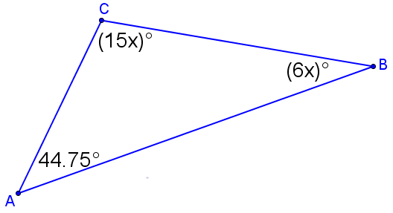 |  | Find $m∠A$, $m∠B$, and $m∠ACB$.  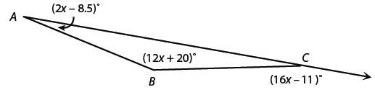
 | Find $m∠B$, $m∠C$, and $m∠D$.  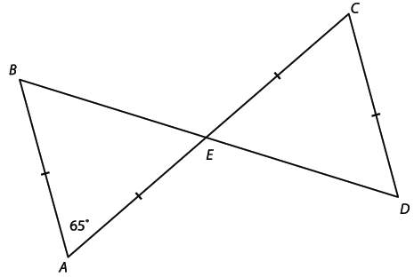 |  | Solve for x given $\overline{NO}$is a midsegment of the triangle.  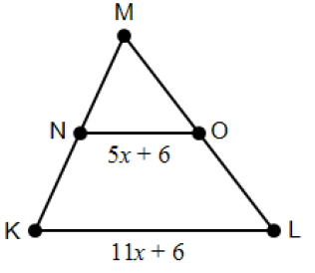

Extended Understanding:
 | Find the length of $\overline{EC}$.  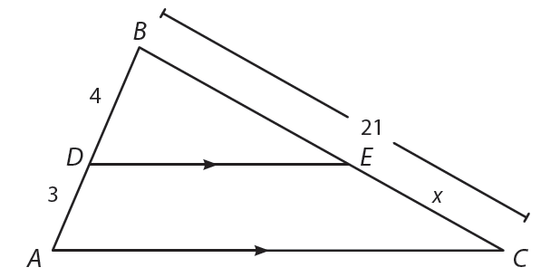 |  | Find the lengths of $\overline{CD} and \overline{BD}$.  