Secondary Math 2 3.0 Homework Name: ________________________ Period: _______

Pythagorean Theorem
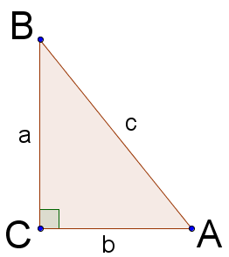 | Named for the Greek mathematician, Pythagoras, this theorem relates the sides of a right triangle with the formula:  $$a^{2}+b^{2}=c^{2}$$  where $a, b$ are the lengths of the legs of the right triangle and $c$ is the length of the hypotenuse of the right triangle.  Points are represented by upper case letters. The side of the triangle opposite the angle at a given point is represented with the lower case version of the same letter (e.g., point B is directly across from the side with a length of b).

Example 1: Find the missing side length of the triangle:
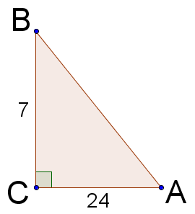 | $$a^{2}+b^{2}=c^{2}$$  $$7^{2}+{24}^{2}=c^{2}$$  $$49+576=c^{2}$$  $$625=c^{2}$$  $$±25=c$$  $$25=c$$ | Write the Pythagorean Theorem.  Use information from the figure.  Evaluate the exponentials.  Addition.  Square root each side.  We prefer to consider distances as positive values, so we eliminate the negative solution.

The Distance Formula
The Pythagorean theorem helps us find the distance of a side length of a right triangle. The distance formula is a tool similar to the Pythagorean theorem that helps us find the distance between two points.
$c^{2}=a^{2}+b^{2}$,  𝑎=$x_{2}-x_{1}$,  $$b=y_{2}-y_{1}$$ | Pythagorean Theorem
$$c=\sqrt{{\left(x_{2}-x_{1}\right)}^{2}+{\left(y_{2}-y_{1}\right)}^{2}}$$  Written as:  $$d=\sqrt{{\left(x_{2}-x_{1}\right)}^{2}+{\left(y_{2}-y_{1}\right)}^{2}}$$ | Distance Formula
To find the distance of two points it is sometimes easier to think of it as constructing a right triangle and using the Pythagorean Theorem. | 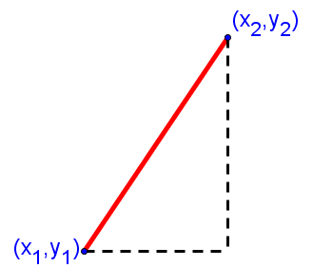
Example 2: Find the distance between the two points:
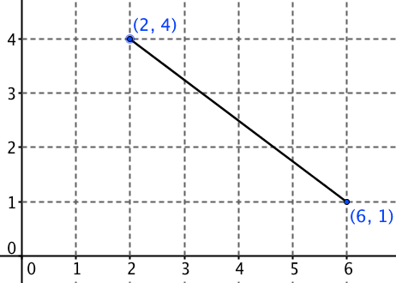 | $$d=\sqrt{{\left(x_{2}-x_{1}\right)}^{2}+{\left(y_{2}-y_{1}\right)}^{2}}$$  $$d=\sqrt{{\left(6-2\right)}^{2}+{\left(1-4\right)}^{2}}$$  $$d=\sqrt{{\left(4\right)}^{2}+{\left(-3\right)}^{2}}$$  $$d=\sqrt{16+9}$$  $$d=\sqrt{25}$$  $$d=5$$ | Write the Distance Formula.  Use information from the figure.  Subtract the numbers in parenthesis.  Evaluate the exponentials.  Addition.  Square root.
Practice Exercises:
Pythagorean Theorem
Find the missing side lengths of the right triangles using the Pythagorean Theorem given $∆ABC$:
1) | $a=5, b=6;$Find $c$. | 2) | $a=6, b=8;$Find $c$. | 3) | $a=5, b=12;$Find $c$.

Distance Formula
Find the distance between the two given points.
4) | $$\left(1,3\right) and \left(4,2\right)$$ | 5) | $$\left(-6,3\right) and \left(5,-3\right)$$ | 6) | $$\left(7,4\right) and \left(7,8\right)$$
7) | $$\left(1,1\right) and \left(-4,-2\right)$$ | 8) | $$\left(10,-1\right) and \left(4,3\right)$$ | 9) | $$\left(5,0\right) and \left(-1,2\right)$$

