**Secondary Math 2 3.1 Homework Name: \_\_\_\_\_\_\_\_\_\_\_\_\_\_\_\_\_\_\_\_\_\_\_\_ Period: \_\_\_\_\_\_\_**

**Dilations**

1. **The following are dilations. Decide whether each is an enlargement or a reduction. Find the scale factor. *\*Solid lined figures are Pre-Images***

|  |  |  |  |  |  |
| --- | --- | --- | --- | --- | --- |
| a) |  | b) | AG U1L1_011 | c) |  |

1. **Draw the dilation image of each pre-image with the given center and scale factor.**

|  |  |  |  |  |  |
| --- | --- | --- | --- | --- | --- |
| a) | Center $(0,0)$; scale factor 3 | b) | Center $(3,4)$; scale factor $\frac{1}{3}$ | c) | Center $(3,5)$; scale factor $\frac{1}{2}$ |

**Review Problems:**

|  |  |  |  |
| --- | --- | --- | --- |
|  | What is the most precise definition of the quadrilateral formed by the given vertices? $A\left(0,2\right), B\left(2,5\right), C\left(5,5\right), D(4,2)$     Conclusion: |  | Solve for x and y given ABCD is a parallelogram: |
|  | Solve for x: |  | Solve for x then solve for $m∠A$ and $m∠B$. |

**Extended Understanding:**

1. On-Board, a luggage manufacturer, has had great success with a certain model of carry-on luggage. Feedback suggests that customers would prefer that the company sell different sizes of luggage with the same design as the carry-on. The graph below represents the top view of the original carry-on model and a proposed larger version of the same luggage. Does the new piece of luggage represent a dilation of the original piece of luggage? Why or why not?

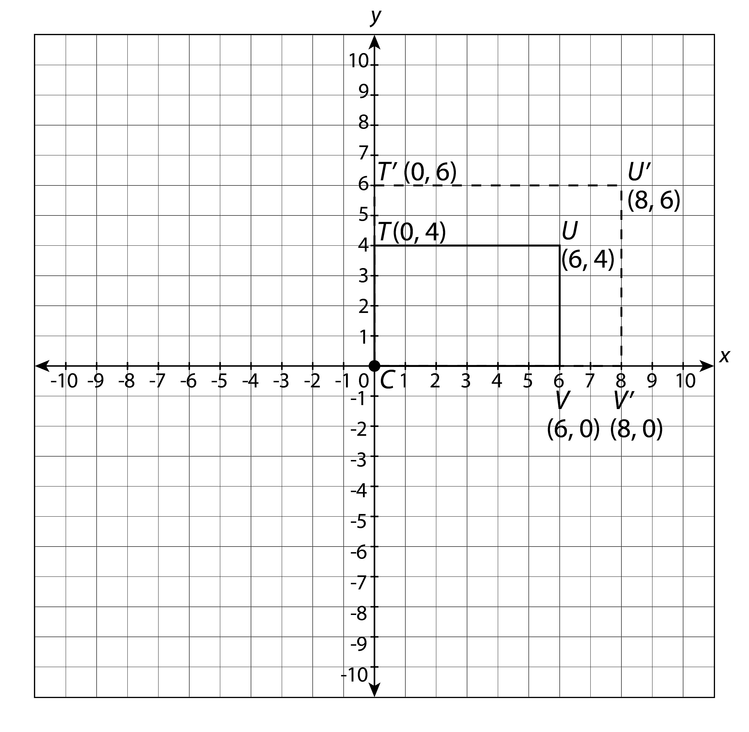

1. Determine whether each statement is true or false. **Justify your answers**.
   1. A dilation with a scale factor greater than 1 will shrink the image.
   2. For a dilation, corresponding angles of the image and pre-image are congruent.
   3. A dilation image cannot have any points in common with its pre-image.
   4. A dilation preserves length/distance.