Secondary Math 2 3.3 Homework Name: _________________________ Period: _____

Proofs with Similar Triangles

- Decide whether the following triangles are similar; if they are, state 1) the similarity postulate that justifies your answer and 2) the similarity statement.
a) | 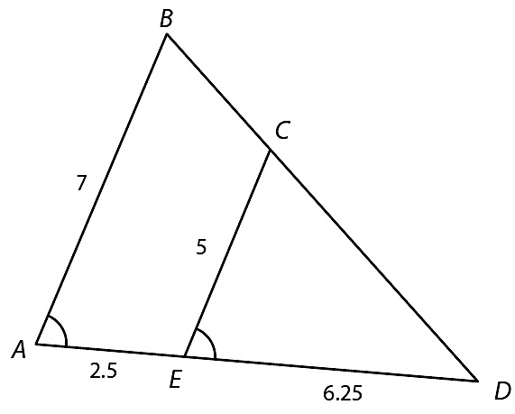 | b) | 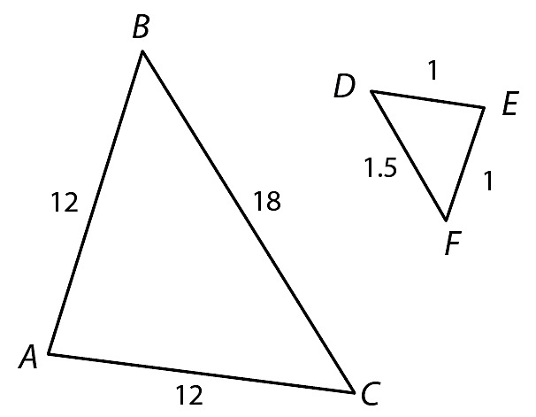 | c) | 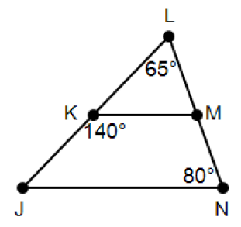

- Find all the angle measures and side lengths for each triangle of the given similar pairs.
a) | $$⊿ABC \sim ⊿DEF$$  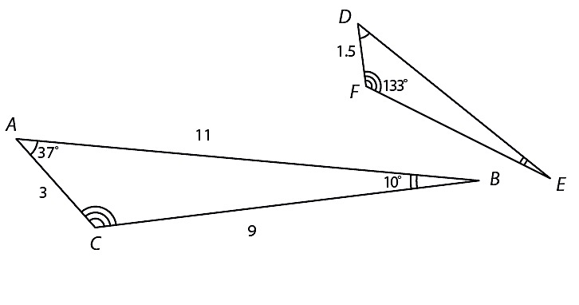 | b) | $$⊿JKL\sim ⊿MNP$$  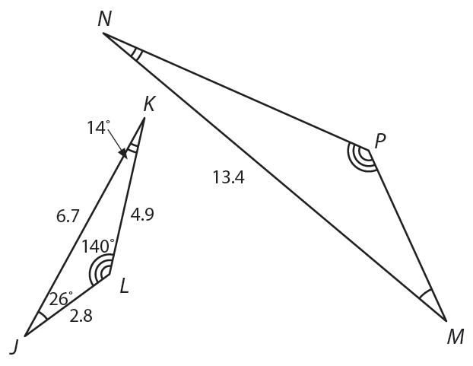

Review Problems:
 | Solve for x: |  | Solve for x:  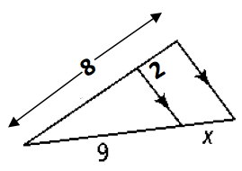
 | Find $m∠A$, $m∠B$, and $m∠C$.  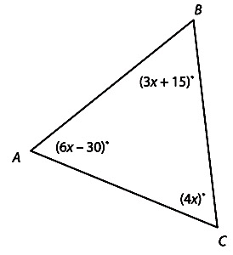 |  | Find the length of $\overline{FG}$ given that $\overline{IJ}$ is a midsegment of the triangle.  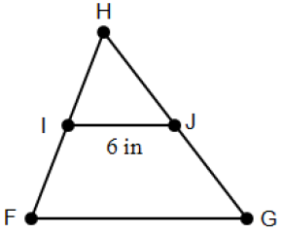

Extended Understanding:
- To measure$\overline{BC}$ , the distance across a lake, a surveyor stands at point A and locates points B, C, D, and E. If $⊿ABC\sim ⊿ADE$ what is the distance across the lake?
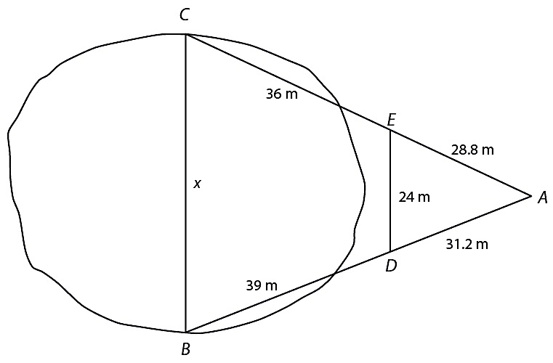

- Sheila is standing near the Eiffel Tower in Paris, France. The shadow of the monument is 580 feet long, and Sheila’s shadow is 3 feet long. If Sheila is 5 feet 6 inches tall, how tall is the monument?
