Secondary Math 2 8.0 Homework Name: ________________________ Period: _______
Interval Notation:
Interval Notation is used as an alternative method of expressing inequalities. It represents all REAL numbers in a specified interval. The use of soft brackets ( or ) indicate that the endpoint is not included or that the interval is open. The use of hard brackets [ or ] indicate that the endpoint is included or that the interval is closed. We always list the endpoints of the interval in order of least to greatest. Since $∞$ is a concept and cannot actually be reached, you will always use a soft bracket on either $+∞$ or $-∞.$
Example:
- $x>6$ would be expressed as $\left(6, ∞\right)$
- $x≤0$ would be expressed as $\left(-∞,0\right]$
- $-2<x≤8$ would be expressed as $\left(-2, 8\right]$
- $x<-1$ or $x>3$ would be expressed as $\left(-∞, 1\right)∪\left(3,∞\right)$ *where the $∪$ stands for “union” (oftentimes we leave out the $∪$ and assume it to be implied, in which case $\left(-∞,1\right)\left(3,∞\right)$
Problem Sets: Fill in the missing portions of the table.
 | Inequality or Set | Graph | Interval Notation
 | $$x>-6$$
 |  | 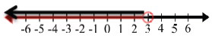
 |  | 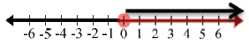
 | $$x≤-5$$
 |  |  | $$\left[-6, ∞\right)$$
 | $$x>5$$
 |  |  | $$\left(-3, ∞\right)$$
 |  | 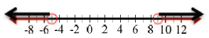
 |  | 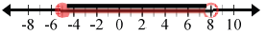
 | $$-12≤x≤2$$
 |  |  | $$\left(-∞,-12\right]∪\left[0, ∞\right)$$
 | $x$ is all Real numbers

