Match the parametric equations with their graphs.
1. 2.

Sketch the curve given by the parametric equations.

3. 4.

(Set Tmin: -2 and Tmax: 3) (Set Tmin: 0 and Tmax: 4)

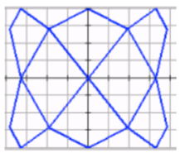
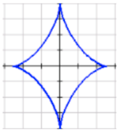
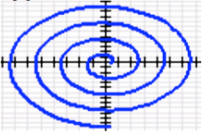
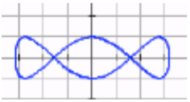
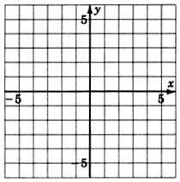
5. Bryce Harper hits a baseball 3 feet above the ground, with an initial velocity of 100 ft/sec at an angle of 15° with the horizontal. Using the following parametric equations, will the ball clear a 10 foot wall that is 400 feet away? Draw a picture to help you answer the question.
 | Unit 12 Review
SM3H | Polar and Parametric Equations | Unit 12

Name: _______________________________________________________ Period: ________

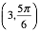
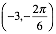
6. Let’s say that Bryce Harper tries to hit the ball again, but this time with an angle of 23° with the horizontal. Using the new parametric equations, does he hit a home run? Draw a picture to help you answer the question.

Plot the points with the given polar coordinates.

7. 8. 9.

Use algebra to find the rectangular coordinates of the points with the given polar coordinates.

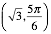
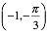
10. 11.

Use algebra to find the polar coordinates of the points with the given rectangular coordinates.

12. $(2, -1)$ 13. $(1, 3)$
Convert the following equations from rectangular form to polar form.

13. 14.

Convert the following equations from polar form to rectangular form.

15. 16.

17. The locations of two UFOs in the night sky above BYU Stadium, given in polar coordinates, are (27mi, 122°) and (31mi, 97°). Find the distance between the two UFOs. First, draw a picture.

WITHOUT A CALCULATOR, determine the number of petals on each rose curve, given the following equations. Then list how long each petal is.
18. 19. 20.

WITHOUT A CALCULATOR, determine what type of limaçon is represented by the following equations.
21. 22. 23.

WITHOUT A CALCULATOR, sketch the graph of each polar curve. Then name the type of polar curve. Show all work.
24. 25. 26.

27. 28. 29.

Graph each number in the complex plane, and find its absolute value.
30. 31. 32.

Express each complex number in polar form.

33. 34.

Graph each complex number on a polar grid. Then express it in rectangular form.

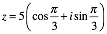
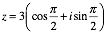
35. 36.

Find each product or quotient. Then express it in rectangular form.

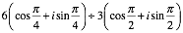
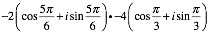
37. 38.

Find each power. Then express it in rectangular form.

39. ${\left(4-i\right)}^{5}$ 40.

Find all the distinct pth roots of the complex number.
41.

