Name: ______________________________________ Period: ________

Sequences and Series Review

1. Find the 32nd term of each sequence.
- -9, -8.7, -8.4, . . . | - 101, 105, 109, 113, . . .

- What are the second and third terms of the arithmetic sequence 80, _____, ______, 125, . . .
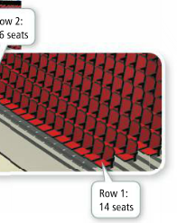
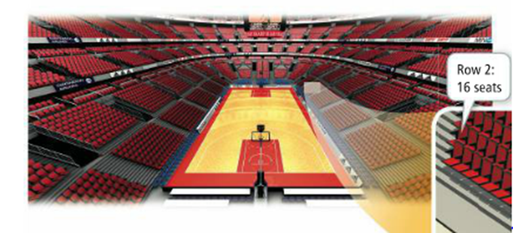
- The numbers of seats in the first 13 rows in a section of an arena form an arithmetic sequence. Rows 1 and 2 are shown in the diagram below. How many seats are in Row 13?

Write the next 3 terms of the pattern. Then write the explicit and recursive rule for the following arithmetic sequences:
 | $$18, 22, 26, 30, …$$ |  | $$11, 6, 1, -4,…$$

Write the next 3 terms of the pattern. Then write the explicit and recursive rule for the following geometric sequences:
 | $$-4, 12, -36, 108…$$ |  | $$9, 1,\frac{1}{9},\frac{1}{81}, \frac{1}{729}, …$$

Find the sum of the arithmetic sequence.
 | Find the sum of the sequence of the first 22 terms: $a_{n}=3n-6$ |  | Find the sum of the first 98 terms.  -17, -9, -1, 7, 15 …

Find the sum of the geometric sequence.
 | Find the infinite sum of  $$a_{n}=2{\left(-\frac{1}{5}\right)}^{n}$$ |  | Find the sum of the sequence of the first 16 terms.  $$-12, -4, -\frac{4}{3}, -\frac{4}{9} , …$$

Find the 24th term of the sequence.
 | $$19, 14, 9, 4, …$$ |  | $$1,\frac{3}{4},\frac{9}{16},\frac{27}{64},…$$

Use Pascal’s Triangle to do the following
Multiply the binomial: ${\left(2-x\right)}^{6}$

Multiply the binomial: ${\left(2x+7\right)}^{4}$

Find the 4th term of the expansion: ${\left(x-5\right)}^{9}$

Determine whether each infinite geometric series diverges or converges. Find the sum if the series converges.
 | $$\frac{1}{6}+\frac{1}{10}+\frac{3}{50}+\frac{9}{250}…$$ |  | $$3+\frac{9}{2}+\frac{27}{4}+\frac{81}{8}…$$
 | $$\sum_{n=1}^{∞}{\left(\frac{1}{3}\right){\left(\frac{-5}{4}\right)}^{n}}$$ |  | $$\sum_{n=1}^{∞}{{\left(\frac{-7}{8}\right)}^{n}}$$

