Secondary 3 Honors: Unit 8 Trigonometry REVIEW Name: __________________________________________ Per: ________
- Write the ratio of the six trigonometric functions of the angle .
4
5
3
A
C
B
$\sin{θ= \csc{θ=}}$
$\cos{θ= \sec{θ=}}$
$\tan{θ= \cot{θ=}}$

- You are standing 25 feet from the foot of tree, the angle of elevation to the top of the tree is 32 $°$. Find the height of the tree to the nearest foot.

- Convert the following from degrees to radians or from radians to degrees.
  - $200°$

  - $415°$

  - $600°$

  - $\frac{8π}{9}$

  - $\frac{6π}{4}$

  - $\frac{5π}{3}$

- Fill in the missing values on the unit circle AND then evaluate the functions without using a calculator.
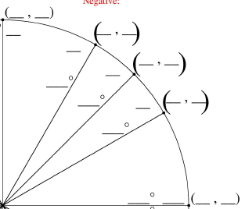
  - $\sin{\frac{7π}{6}}$

  - $\cos{\frac{7π}{6}}$

  - $\sin{\frac{2π}{3}}$

  - $\cos{\frac{5π}{4}}$

Graph the following functions by hand. Find the amplitude, period, domain and range for each.
- Graph two full periods of $y=4\tan{x}$ | - Graph two full periods of $6\cos{8x}$
- Graph two full period of $y=\sin{(x+π)}+5$ | - Graph two full periods of $y=\csc{x }$
- Graph two full periods of $y=\sec{x }$ | - Graph two full periods of $y=\cot{x }$

- Label each of the graphs with their equation.

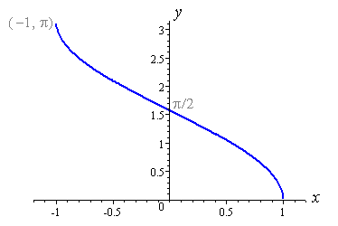 | 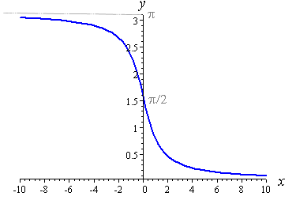 | 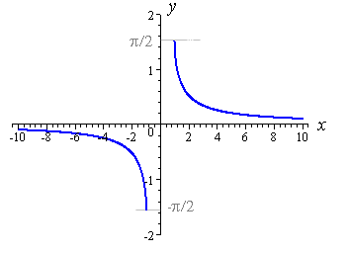
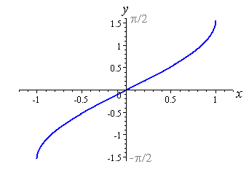 | 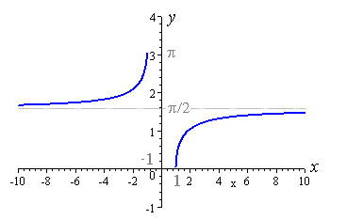 | 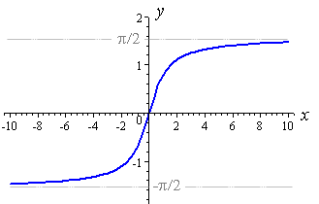

CHALLENGE PROBLEMS!!!!!
- At the Delaware State Fair, there is a Ferris wheel with a 24 meter diameter. The center of the Ferris wheel is 15 meters off the ground. The Ferris wheel completes one rotation in 48 seconds.

- Write an equation to model the height of a rider on this Ferris wheel $h$ at any time $t$, where $t=0$ is when the rider is at the position on the Ferris wheel farthest to the right.

- Revise your equation so that $t=0$ when the rider is at the bottom of the Ferris wheel.

- What is the height of the rider at 42 seconds?

- San Francisco Bay is an inlet of the Pacific Ocean. At a dock, the depth of the water is 3 feet at low tide and 71 feet at high tide, 4 hours later. Draw a graph showing the depth of the water and write a function that models the water’s depth at any time $t$.

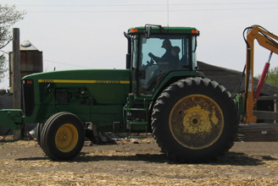
- On tractors, rolling circumference can be defined as the distance a tire travels in one revolution. Since both the front and the rear tire on tractors are engaged, the front tire requires more revolutions to cover the same distance as the rear tire. On one particular tractor, the front tire has an 18-inch radius and the rear tire has a 48-inch radius.
- Find the circumference of each tire.

- If the tractor travels 6,336,000 inches (100 miles), how many times does each tire rotate?

- How many more times does the front tire rotate than the back tire?

