Secondary Math 2 4.2 Homework Name: ________________________ Period: _______

Circles and Arc Length
Conceptual Understanding:
 | 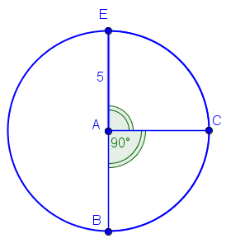  - Length of $\hat{BCE}=$  - Area of sector $BCE=$ |  | 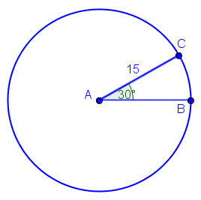  - Length of $\hat{BC}=$  - Area of sector $BC=$

Review Problems:
 | Find the $m∠DCE$.  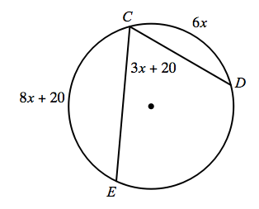 |  | Find $m\hat{XY}$.  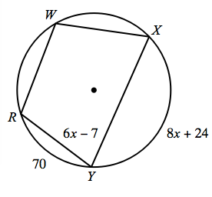
 | Find the $m∠ECD$. Assume $\overline{EC}$ is a diameter.  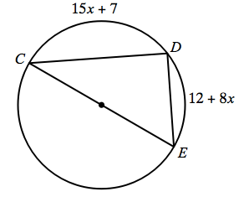 |  | Find the $m∠FEG$.  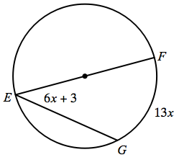

Extended Understanding:
 | The area of the small sector is $20π ft^{2}.$ What is the radius of the circle?  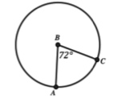 |  | The arc length of $\hat{DF}$ is 30 m. What is the area of the circle?  