Secondary Math 2 5.1 Homework Name: ________________________ Period: _______

Exponent Rules

- Simplify each expression. Make sure your answers do not contain negative exponents.
a) | $$x^{7}∙x^{3}=$$ | b) | $$\frac{x^{4}}{x^{6}}=$$ | c) | $${\left(x^{2}\right)}^{3}=$$

- Simplify each expression. Make sure your answers do not contain negative exponents.
a) | $$\frac{3x^{-1}y^{2}}{4x^{-3}y^{0}}=$$ | b) | $$\frac{x^{11}y^{10}}{x^{-3}y^{18}}=$$ | c) | $$\frac{4x^{3}n^{3}}{2n^{-3}}=$$

Review Problems:
 | Solve for x. Assume lines that appear to be tangent are tangent:  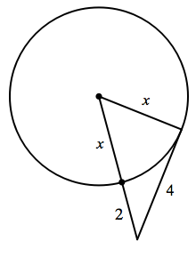 |  | Find the value of t. Assume $m\hat{CB}\tilde{=}m\hat{DB}$.  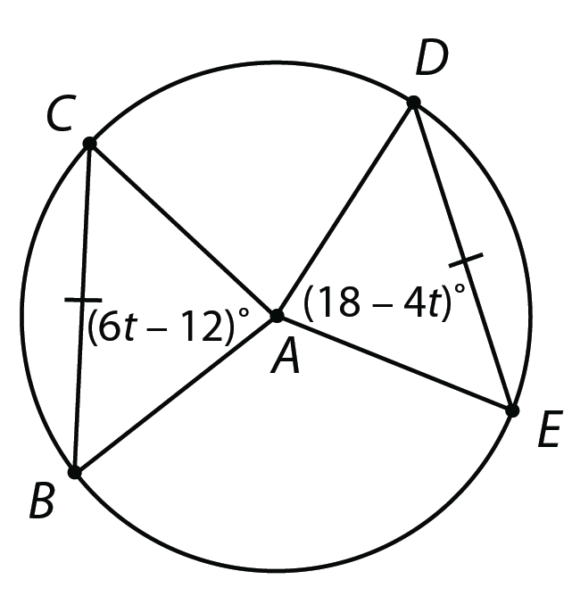
 | Solve for x and y: |  | A stick 2 m long is placed vertically at point B. The top of the stick is in line with the top of a tree as seen from point A, which is 3 m from the stick and 30 m from the tree. How tall is the tree? (hint use similar triangles)  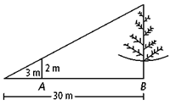

Simplify each expression. Your answers should contain only positive exponents.
 | $$\frac{{\left(2m^{2}n^{3}\right)}^{4}}{mn^{3}∙m^{2}n^{3}∙m^{3}n^{0}}$$ |  | $$\frac{2x^{4}y^{-2}∙2x^{-4}y^{-1}}{{\left(2x^{3}y^{3}\right)}^{-1}}$$

