Secondary Math 2 Unit 12 Review Name: ________________________ Period: _______

1) |  | Find the volume of the solid. The length of the base is $10 in$, the width of the base is $3 in$, and the height of the solid is $7 in$. |  |  |  | 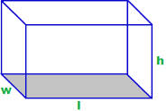
A | $$V=20 {in}^{3}$$ |  | B | $$V=70 {in}^{3}$$ | C |  | $$V=100 {in}^{3}$$ | D | $$V=210 {in}^{3}$$
2) |  | A jar of peanut butter has a base with a radius of 4 cm and a height of 8 cm. Find the volume.
A | $$V=32π {cm}^{3}$$ |  | B | $$V=128π {cm}^{3}$$ | C |  | $$V=\frac{32π}{3} {cm}^{3}$$ | D | $$V=\frac{128π}{3} {cm}^{3}$$
3) |  | Find the volume of the solid. The length of the base is $3 ft$, the width of the base is $4 ft$, and the height of the solid is $6 ft$. |  |  |  | 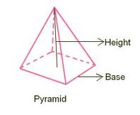
 | A $V=8 {ft}^{3}$ |  | B | $$V=13 {ft}^{3}$$ | C |  | $$V=24 {ft}^{3}$$ | D | $$V=72 {ft}^{3}$$
4) |  | Find the volume of the solid. The radius of the base is $6 cm$ and the height of the solid is $11 cm$. |  |  |  | 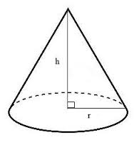
A | $$V=396π {cm}^{3}$$ |  | B | $$V=22π {cm}^{3}$$ | C |  | $$V=66π {cm}^{3}$$ | D | $$V=132π {cm}^{3}$$
5) |  | Find the volume of the solid. The radius of the sphere is $2 m$. |  |  |  | 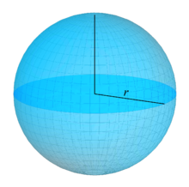
A | $V=8π m^{3}$ |  | B | $$V=\frac{16π}{3} m^{3}$$ | C |  | $$V=\frac{32π}{3} m^{3}$$ | D | $$V=\frac{8π}{3} m^{3}$$

6) |  | Find the area of the polygon. Assume the measurements are given in miles. |  |  |  |  | 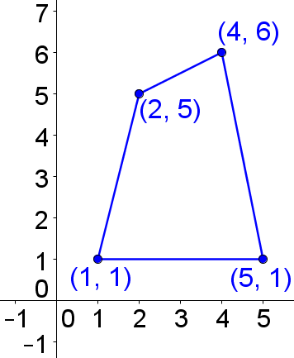
A | $$A=6.5 {mi}^{2}$$ |  | B | $$A=13.5 {mi}^{2}$$ | C | $$A=7 {mi}^{2}$$ |  | D | $$A=14 {mi}^{2}$$

7) |  | 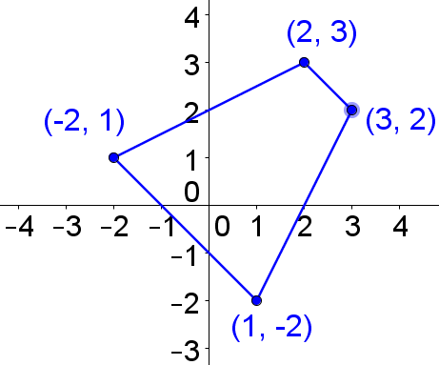 |  |  |  |  | Find the area of the polygon. Assume the measurements are given in inches.
A | $$A=12 {in}^{2}$$ |  |  | B |  | $$A=12.5 {in}^{2}$$ |  |  |  | C | $$A=13 {in}^{2}$$ |  |  |  | D | $$A=13.5 {in}^{2}$$
8) |  | Find the area of the polygon. Assume the measurements are given in centimeters. |  |  |  |  |  |  |  |  |  | 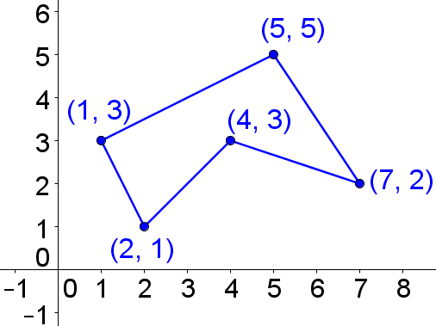
A | $$A=13 {cm}^{2}$$ |  | B |  | $$A=14.5 {cm}^{2}$$ |  |  | C | $$A=14 {cm}^{2}$$ |  |  |  | D | $$A=9.5 {cm}^{2}$$

9) A rectangular pyramid has a volume of 30 cubic inches. What is one possible set of dimensions for the pyramid?

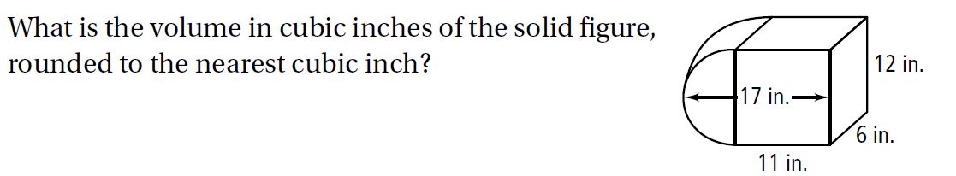
10)

11) Two similar cones have heights 4 m and 12 m.
a. What is the ratio of their heights?

b. What is the ratio of their surface areas?

c. What is the ratio of their volumes?
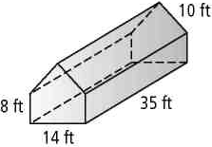
12) A greenhouse has the dimensions shown in the figure. What is the volume of the greenhouse? Round to the nearest cubic foot.

13) If you need 3 gallons of paint to cover a wall 10 feet high, how much paint would you need to cover a similar wall that is 15 feet high?

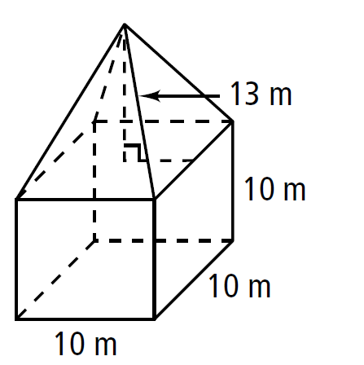
14-15: Find the volume.
14) 15)
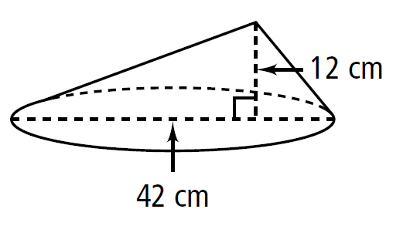

16) A milk jug shaped like a cylinder has a base area of 100 cm² and can hold 1500 cm³ of milk. The height of the juice container is:

17) Find the diameter of a soccer ball with a volume of 1436.76 in³ to the nearest inch.

